Victor Nguyen

Professor Hadaegh

CS 443

15 April 2020

**Lab 5**

**Question 1:**

Use extended hashing technique to insert the employees in which their corresponding binary Empl_IDs are shown below. Assume you can have two employees per block. Show the depth of both global and local directories. The bits should be considered from left to right as shown in the lecture..

**00001, 10000, 10100, 00111, 11011, 11101, 10010, 01111, 10101**

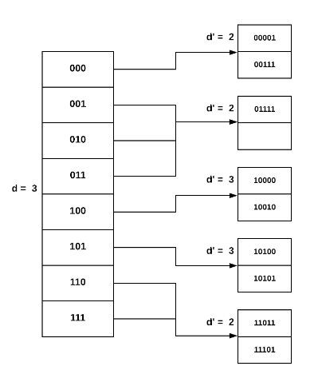

**Question 2:**

Use extended hashing technique to insert the employees in which their corresponding binary Empl_IDs are shown below. Assume you can have two employees per block. Show the depth of both global and local directories. The bits should be considered from left to right as shown in the lecture.

**01011, 01010, 11110, 10000, 10010, 11111**

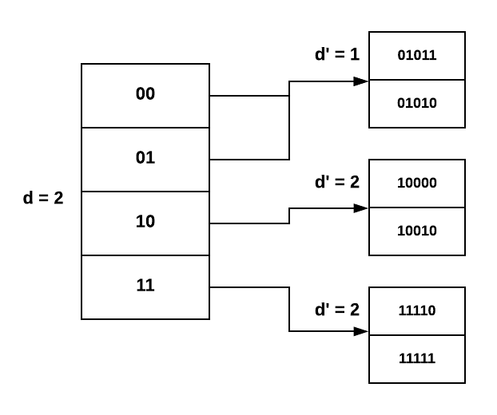

**Question 3:**

Consider the following records of question 1: (Again Digits should be considered from left to right)

**00001, 10000, 10100, 00111, 11011, 11101, 10010, 01111, 10101**

Load the records into files using Dynamic Hashing Scheme. You can put two records per block. Show the directory at each step, and the global and local depths.

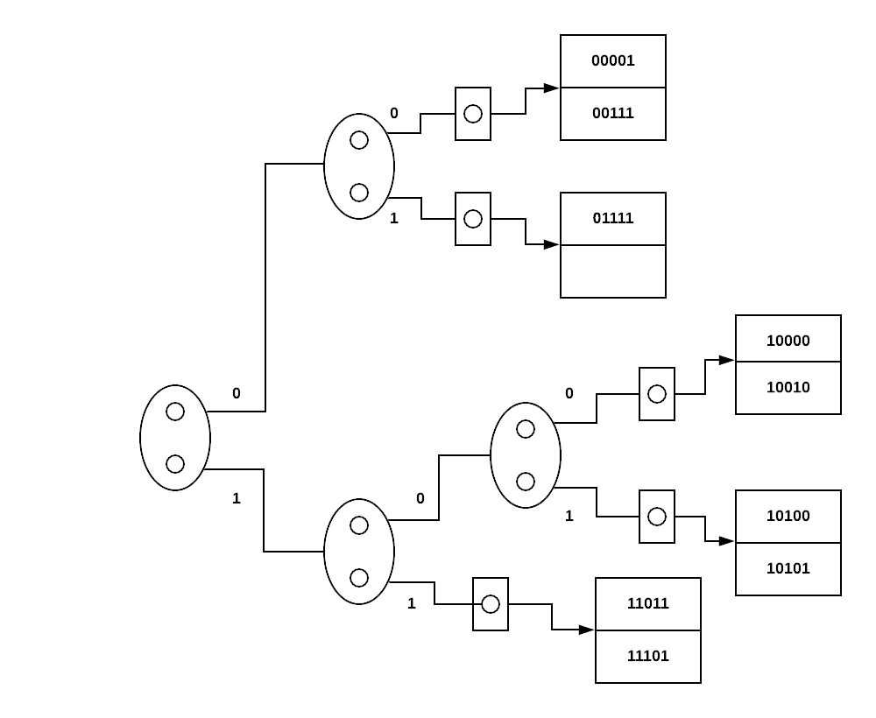

**Question 4:**

Consider the following records of question 1: (Again Digits should be considered from left to right)

**01011, 01010, 11110, 10000, 10010, 11111**

Load the records into files using Dynamic Hashing Scheme. You can put two records per block. Show the directory at each step, and the global and local depths.

